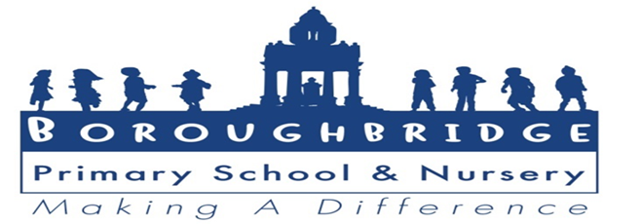

A meeting of the Governing Board of Boroughbridge Primary School and Nursery
will be held on Tuesday 19th December 2023 at 5.30.pm.

AGENDA

No. | Item | Lead | Time
1. | Welcome and Introductions | Chair | 2
2. | Associate member – consider approval and term of office | Chair | 5
3. | Apologies for absence | Chair | 2
4. | Confidentiality and declaration of interests | Chair | 2
5. | Notification of urgent other business previously notified to the Chair | Chair | 5
6. | Approval of the Minutes of the Board of Governors meetings held on 23rd November 2023 | Chair | 5
7. | Matters arising from the minutes not included in other agenda items  - GB130/23 update of school residential  - GB111/23 School parking update | Chair | 10
8 | Confirm date of next meeting on 1st February 2023 | Chair | 2
9 | Published Admissions Number  - Consider if any amendment is necessary | Head | 5
10 | Finance: report  - Breakfast and after school report  - Review monitoring reports  - Agree revised budget | SB  CS  CS | 20
11 | Any Other Business (under item 4 above) | Chair | 5
12 | How has this meeting impacted on the welfare and progress of our pupils? | All | 5

