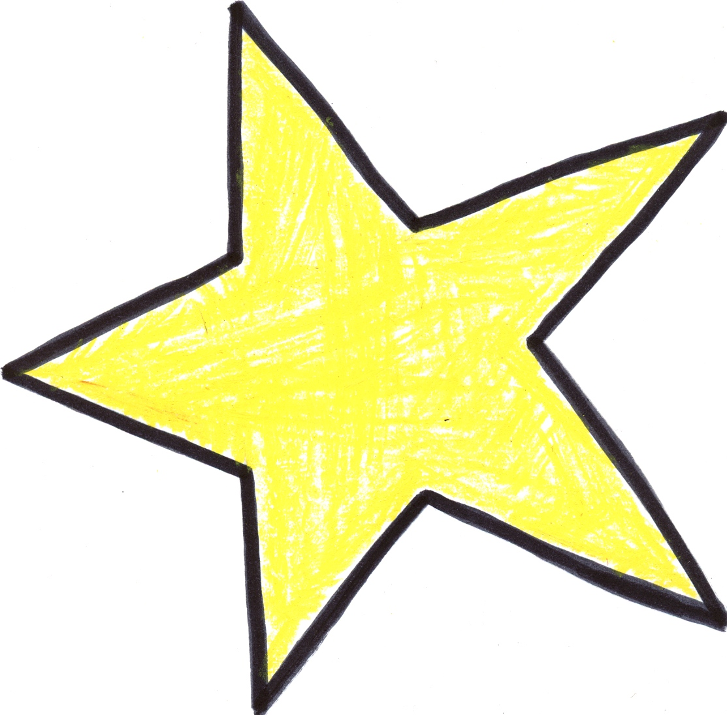

photo or self-portrait
My name is:

I like to be called:
This is Me

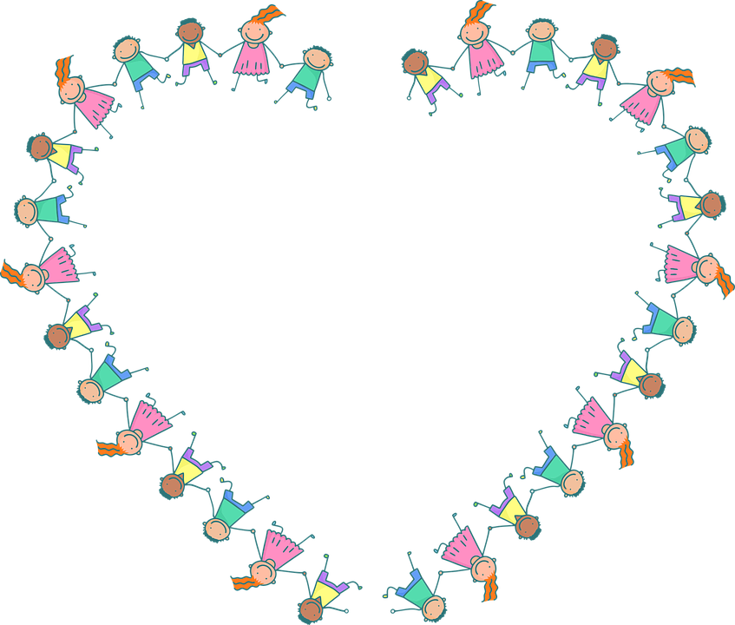
We hope you will take the time to talk to your child and fill in these pages together before they start Nursery.
Your child might like to draw, and you could write.
These are the people who are important to me.
This is what we like to do together.



These are some things which make me feel happy.
These are some things which might make me feel sad or worried.

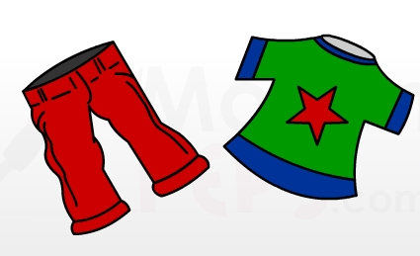
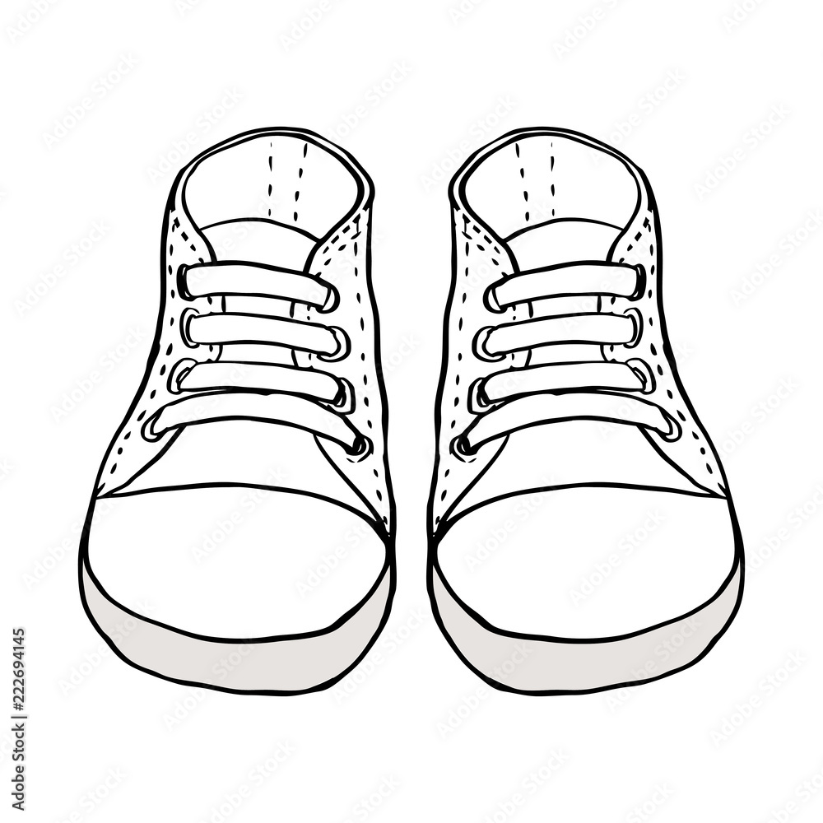
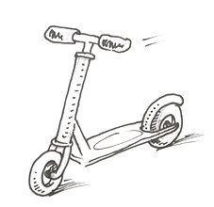

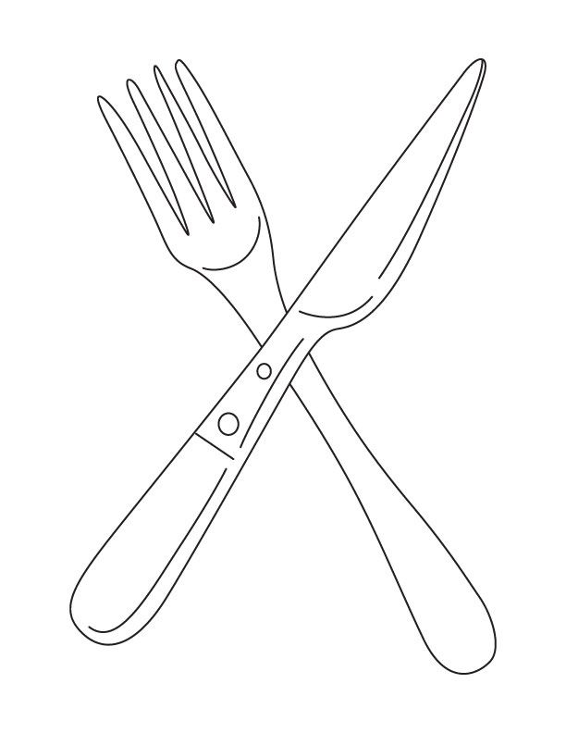
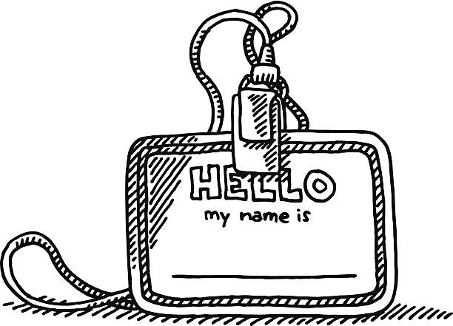
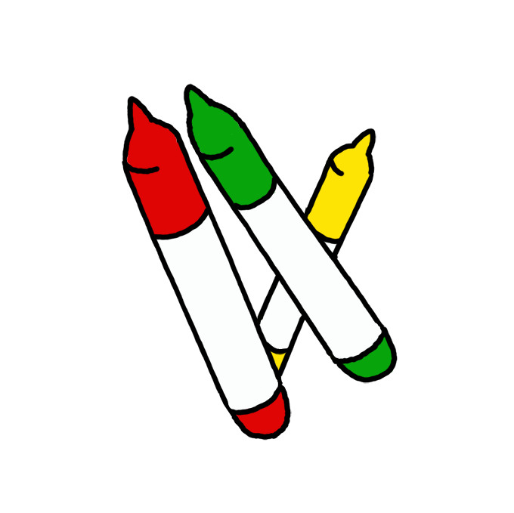
Things I can do by myself (please tick):
Use the toilet
Talk about how I am feeling
Get dressed
Use a knife and fork
Put my shoes on
Recognise my name
Ride a scooter
Draw a picture

Use this space to tell us anything else you would like us to know about your child before they start Nursery. We very much look forward to getting to know you and your child during their time with us. Thank you for taking the time to complete this booklet.
Signed (parent/carer):

