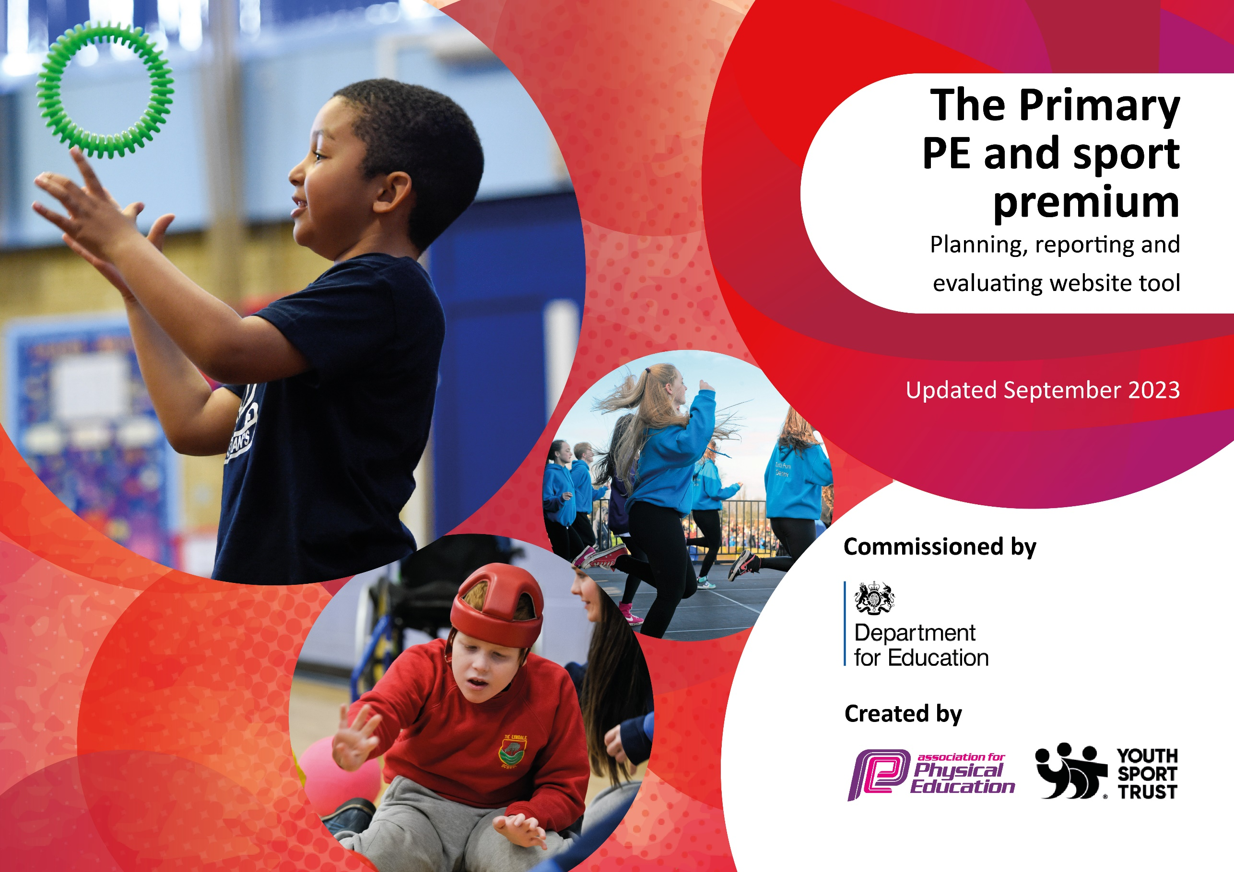

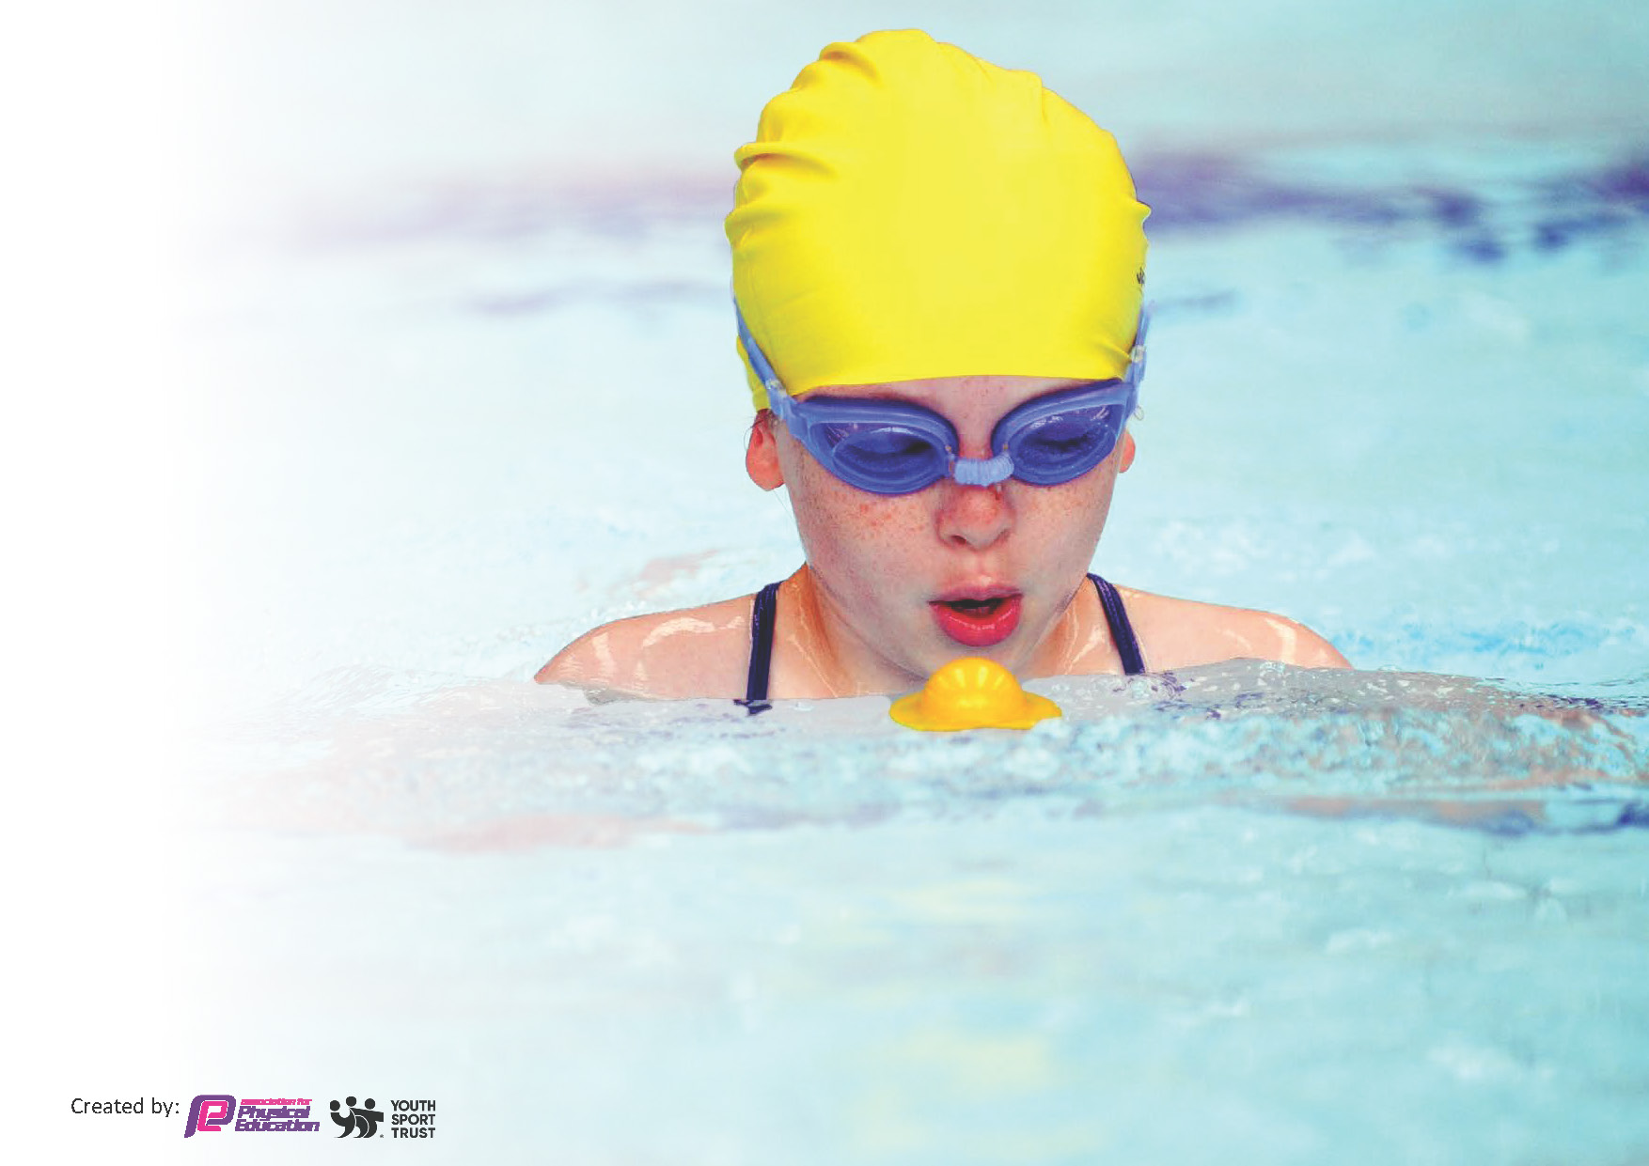
This template can be used for multiple purposes:
by:
- It enables schools to effectively plan their use of the Primary PE and sport premium
- It helps schools to meet the requirements (as set out in guidance) to publish information on their Primary PE and sport premium
- It will be an effective document to support Ofsted inspections enabling schools to evidence progress in Physical Education (PE) and evidence swimming attainment, which forms part of the PE National Curriculum. We would recommend schools consider
the Intent, Implementation and Impact of any spend, as examined within the Education Inspection Framework.

It is important that your grant is used effectively and based on school need.

Schools must use the funding to make additional and sustainable
improvements to the quality of the PE, School Sport and Physical Activity (PESSPA)
they offer. This means that you should use the Primary PE and sport premium to:

- Build capacity and capability within the school to ensure that improvements made now will benefit pupils joining the school in future years
- Develop or add to the PESSPA activities that your school already offers.

The Primary PE and sport premium should not be used to fund capital spend projects; the school’s core budget should fund these. Further detail on capital expenditure can be found in the updated Primary PE and sport premium guidance.

The Primary PE and sport premium guidance, outlines 5 key priorities that funding should be used towards. It is not
necessary that spending has to meet all the key priorities, you should select the priorities that you aim to use any funding towards.

Although completing this template is not a requirement for schools, schools are required to publish details of how they spend this funding. Schools must also outline what the impact this funding has had on pupils’ PE and sport participation and attainment and how any spending will be sustainable in the future. All funding must be spent by 31st July 2025.

The Department for Education has worked closely with the Association for Physical Education (afPE) and the Youth Sport Trust (YST) to develop this template and encourages schools to use it. This template is an effective way of meeting the reporting requirements of the Primary PE and sport premium.

Review of last year’s spend and key achievements (2024/2025)

We recommend you start by reflecting on the impact of current provision and reviewing your previous spend.

Activity/Action | Impact | Comments
PE celebrated alongside academic achievements in whole school assemblies. Children share medals and awards etc achieved at swimming lessons, gymnastics, dance, triathlon, cricket, football etc in class or whole school assembly.  Children’s sporting achievements outside of school are celebrated.  Pupils achievements to improve attendance and enhance pupil well-being and progress and attainment across the curriculum have been celebrated.  Certificates to be handed out for achievements for sports events. | All children have opportunity at some point in the year to share their achievements in PE  Parents share in children’s success through newsletters, DOJO and social media.  Children’s achievements evidenced and valued.  Children excited to talk about sport and their success.  Children encouraged to try new sports and inspired by role models | Maintain the % of children taking part in competitive activity.  Ensuring it is part of what they do at school.  Ensure good role models  Invite any sporting personalities into school so pupils can identify with success.  Sports lead to speak to Sport England and local sports teams about school visits.  Continue to work with Premier Sports.

Key priorities and Planning
This planning template will allow schools to accurately plan their spending.

Action – what are you planning to do | Who does this action impact? | Key indicator to meet | Impacts and how sustainability will be achieved? | Cost linked to the action
Encourage greater proportion of physical activity within break times by offering a wider range of lunchtime activities for pupils to take part in.  All pupils to receive 2 PE sessions a week each being 1 hour.  School games leaders providing physical activity support for EYFS and KS1 pupils.  Track pupil participation through pupil questionnaires from sports lead.  Audit attendance at clubs.  PE questionnaire to be completed to gauge child participation and enjoyment.  Provide a wider range of extra-curricular clubs including gymnastics and Forest schools.  Premier Sports club to lead active lunchtime clubs twice a week  Participation in outside competitions.  Daily participation in a whole class run to support pupil health and fitness.  Admin to provide coordination of events, booking and analysis of data.  Sports coaches working in school with the children and with the staff to ensure a wide range of sports is offered to all pupils.  Pupils experience physical activities which can become hobbies & part of an active lifestyle as well as organised sport.  Continue to provide wider range of sports clubs available both after school and at lunch time to give children wider opportunities to take part.  Develop Forest schools sessions within our curriculum  Access for all pupils in Year 6 to participate in a residential of outdoor activities. Contribution towards PPG pupils.  Introduce possible outdoor activity day for Y3/4 (Carlton Lodge) and sleep over events.  Map school grounds for orienteering.  Investigate other sporting events/days in school: balance bikes, hire of climbing wall etc | Lunchtime supervisors / teaching staff, coaches - as they need to lead the activity  Pupils – as they will take part. | Key indicator 2 -The engagement of all pupils in regular physical activity – the Chief Medical Officer guidelines recommend that all children and young people aged 5 to 18 engage in at least 60 minutes of physical activity per day, of which 30 minutes should be in school.  Key indicator 4: Broader experience of a range of sports and activities offered to all pupils. | More pupils meeting their daily physical activity goal, more pupils encouraged to take part in PE and Sport Activities.  Staff enthusiastic and confident in delivering engaging physical activity at lunchtime.  Improved behaviour and attitude.  Children engaged in improving and facing challenges  School games leaders to feedback to sports lead and communicate with their peers (pupil voice)  Staff to deliver Forest school to their year group using their knowledge from previous years Forest School training/CPD.  Specialist resources to be bought so all children can access all areas of the curriculum.  Whole school survey about activities pupils would engage with for active lunchtimes organised by school games leaders.  Purchase of equipment and other resources to encourage children to take part in break time exercise. Restock and purchase new active equipment,  Sports Lead to produce questionnaire to assess effectiveness of lunchtime activities and see where children would like changes.  Children have access to a wide range of PE & sporting activities  Range of activities offered includes activities to engage those children who are less interested in PE  Staff benefit from additional CPD by working alongside PE coaches  Wider range of adventurous activities offered  Increased participation in lunch time and after-school sports clubs.  Access for all-including SEND/ wraparound care.  Look into further access to additional provision such as from Harrogate Town, Boroughbridge tennis centre and other local sports clubs. | Bikeability £54  Forest School £3900

Implement CPD in PE for teachers.  Sports lead to attend any online courses and Premier Sports face to face CPD then cascade learning down through staff meeting.  All pupils access PE lessons that are differentiated and accessible through developing teacher confidence and knowledge.  Upskill Teachers PE knowledge through Premier Sports training and use of planning.  Audit of current skills for all staff in PE  Staff to work alongside coaches in school (Premier Sports and John Dolan) so staff can observe specialists in practice. Subject leader to liaise with SI regularly.  PE lead released to attend free North Yorkshire and York PE lead meetings (cover time and travel costs)  Inspire children to participate in a range of activities through visits by local sports persons/role models.  Sport lead to observe all teachers (including specialist staff) to see what works well and offer challenge in some areas.  Implement ideas gathered at pupil meetings. E.g. growth mindset in PE that can be transferred across the school.  Participate in more cluster sports competitions.  Look into what might be next for those pupils who exceed PE objectives within a competitive sport through cluster sports competitions.  Pupil voice –what other sports would pupils like to try? | Teachers.  Coaches - as they need to lead the activity  Pupils – as they will take part. | Key Indicator 1: Increased confidence, knowledge, and skills of all staff in teaching PE and sport.  Key indicator 5: Increased participation in competitive sport. | Primary teachers more confident to deliver effective PE supporting pupils to undertake extra activities inside and outside of school, including teaching water safety and swimming and as a result improved % of pupil’s attainment in PE.  CPD plan can be implemented which is matched to needs of all staff  All teachers are able to teach the full PE curriculum & make accurate assessments of pupils to inform future teaching and coaching.  Children access high-quality teaching & Learning in PE  School effectively resources to deliver aspects of PE.  Lessons are inclusive for all. All pupils across year groups access the competitions including SEND.  Skill progression is clear through the use of the progression document and Premier Education planning and resource pack.  Resources are used to support the successful delivery of PE  Transport provided to ensure all children have access to competitions  Sports day to remain competitive with additional ways throughout the year to feed into the sports day result.  Competition calendar in place and linked to planned PE curriculum  All children experience competitive sports  Sports day maintains a competitive edge and children have a further reason to compete. | £3821.28 teachers to undertake CPD.  Extra Curricular activities  £6180  Top up swimming £478.32  Transport £395

Key achievements 2024-2025
This template will be completed at the end of the academic year and will showcase the key achievements schools have made with their Primary PE and sport premium spending.

Activity/Action | Impact | Comments
PE has been celebrated alongside academic achievements in whole school assemblies. Children share medals and awards etc achieved at swimming lessons, gymnastics, dance, triathlon, cricket, football etc in class or whole school assembly.  Children’s sporting achievements outside of school are celebrated.  Certificates to be handed out for achievements in sports events.  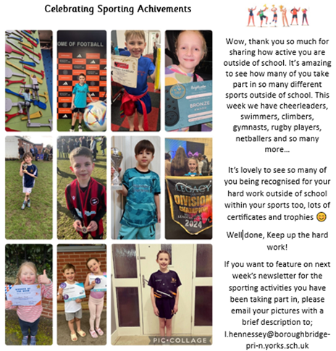  Greater proportion of physical activity taking place during break and lunch times.  All pupils have received 2 PE sessions a week each being 1 hour.  School games leaders have provided physical activity support for EYFS and KS1 pupils.  We have tracked attendance at sports clubs.  Provided a wider range of extra-curricular clubs including gymnastics and Forest schools. These are available both after school and at lunch time to give children wider opportunities to take part.  Forest school sessions have been developed.  Participated in sports competitions and daily whole class run.  Sports coaches have worked in school to ensure a wide range of sports is offered to all pupils.  Access for all pupils in Year 6 to participate in a residential of outdoor activities. Contribution towards PPG pupils.  Track pupil participation through pupil questionnaires.  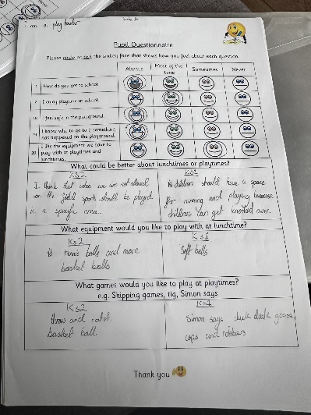  Implement CPD in PE for teachers. Active start training with North Yorkshire Sports and tennis coaching/ lesson planning/ assessment CPD with the LTA.  Sports lead to attend online courses then cascade learning down through staff meeting.  All pupils access PE lessons that are differentiated and accessible through developing teacher confidence and knowledge.  Upskill Teachers PE knowledge through training and use of planning.  Staff to work alongside coaches in school so staff can observe specialists in practice.  PE lead released to attend free North Yorkshire and York PE lead meetings (cover time and travel costs)  Inspire children to participate in a range of activities through visits by local sports persons/role models.  Continue to participate in sports competitions.  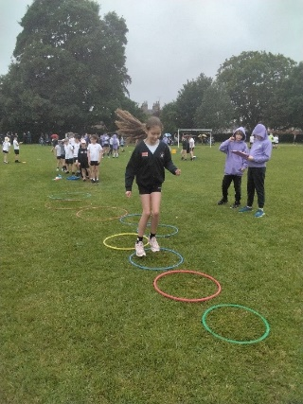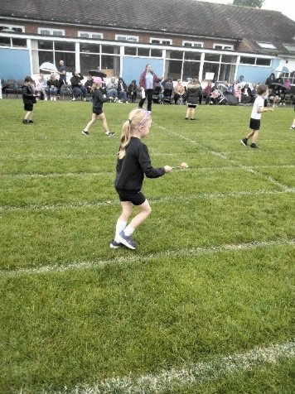 | All children have had the opportunity at some point in the year to share their achievements in PE.  Children’s achievements have been evidenced and valued.  Children are excited to talk about sport and their success.  Children have been encouraged to try new sports and been inspired by role models.  Children are proud of their achievements.  More pupils meeting their daily physical activity goal, more pupils encouraged to take part in the range of PE and Sport Activities provided. Those less interested in PE are taking more of an active part.  Staff enthusiastic and confident in delivering engaging physical activity.  Improved behaviour and attitude with children engaged in improving and facing challenges  Staff confident to deliver Forest school sessions.  Resources have allowed all children to access all areas of the curriculum.  Increased participation in lunch time and after-school sports clubs.  Access for all-including SEND/ wraparound care.  Access to additional provision from Boroughbridge tennis centre has allowed the community to be involved.  Outcome of questionnaires show the effectiveness of lunchtime activities and where children would like changes.  Primary teachers are more confident to deliver effective PE supporting pupils to undertake extra activities inside and outside of school. This includes teaching water safety and swimming.  CPD plan implemented which is matched to needs of all staff  All teachers are able to teach the full PE curriculum & make accurate assessments of pupils to inform future teaching and coaching.  Children access high-quality teaching & Learning in PE  School effectively resources to deliver aspects of PE.  Lessons are inclusive for all. All pupils across year groups access the competitions including SEND.  Skill progression is clear through the use of the progression document and Premier Sports planning and resource pack.  Transport provided to ensure all children have access to competitions  Sports day maintains a competitive edge and children have a further reason to compete.  All children experience competitive sports  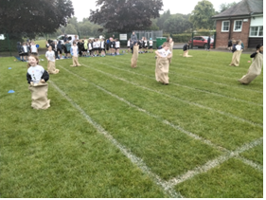 | We need to maintain or increase the % of children taking part in competitive activity.  Continue to ensure good role models  Invite any sporting personalities into school so pupils can identify with success.  Continue to hold Celebration assemblies every Friday to celebrate sporting achievements.  Consider a wider range of adventurous activities.  Continue with the outdoor activity day for Y3/4. This is to take place in October 2025  Questionnaire Results:  100% asked said that they enjoyed playtimes most of the time or Always.  100% said they felt safe on the playground most of the time or Always.  91% answered 'sometimes' to liking the equipment available to play with during break times.  More games were asked for i.e. tig, duck duck goose, simon says - The play leaders implemented these on the KS1 Playground.  More resources for a quieter section of the playground to be able to read or colour etc...  Less football matches were asked for by those who don't play as they kept getting in the way or taking over. Play leaders & staff organised a girls football team & different activities to split up the area and made sure the football stayed in one place.  Outdoor Activity Day for Year 3/4 in October 2025  Update Mapping school grounds for orienteering.  Investigate other sporting events/days in school: balance bikes, hire of climbing wall etc  Look into what might be next for those pupils who exceed PE objectives within a competitive sport through cluster sports competitions.  Pupil voice –what other sports would pupils like to try?  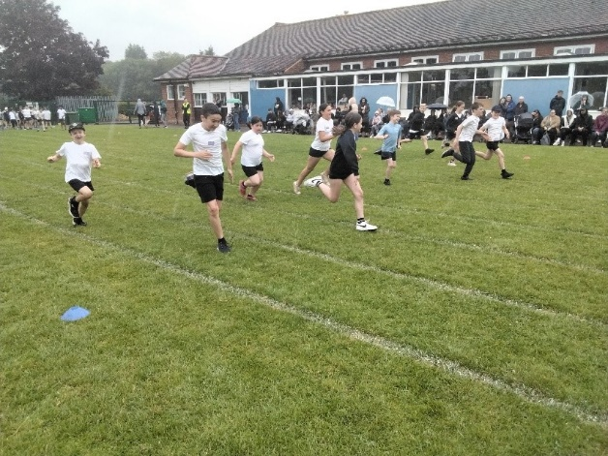

Swimming Data
Meeting National Curriculum requirements for swimming and water safety.
Priority should always be given to ensuring that pupils can perform safe self-rescue even if they do not fully meet the first two requirements of the National Curriculum programme of study

Question | Stats: | Further context  Relative to local challenges
What percentage of your current Year 6 cohort can swim competently, confidently and proficiently over a distance of at least 25 metres? | Current Year 6 cohort: 57% | All KS2 have had swimming lessons. Less children are having lesson outside of school, there are huge waiting lists for swimming lessons so school swimming is more important than ever. All swimmers are taught how to keep themselves safe in and near water.  All Year 4 pupils have swimming lessons including any Year 5 and Year 6 pupils who are still not competent, confident in the water.  3 Year 6 pupils were not given consent to swim by parents.
What percentage of your current Year 6 cohort can use a range of strokes effectively [for example, front crawl, backstroke, and breaststroke]? | 54% | Even though your pupils may swim in another year please report on their attainment on leaving primary school at the end of the summer term 2024

What percentage of your current Year 6 cohort are able to perform safe self-rescue in different water-based situations? | 46%  60%
If your schools swimming data is below national expectation, you can choose to use the Primary PE and sport premium to provide additional top-up sessions for those pupils that did not meet National Curriculum  requirements after the completion of core lessons. Have you done this? | Yes/No
Have you provided CPD to improve the knowledge and confidence of staff to be able to teach swimming and water safety? | Yes/No | Water safety has been taught in lessons in class. We have 2 qualified swimming instructor on the staff team and 2 teachers who swim competitively.

Signed off by:
Head Teacher: | Emma Ryan
Subject Leader or the individual responsible for the Primary PE and sport premium: | Emma Ryan – Headteacher  Victoria Barker – PE Subject Lead
Governor: | Jules Preston
Date: | July 2025

