

Reading at

Boroughbridge Primary School and Nursery

At Boroughbridge Primary School and Nursery, we strive to create a reading culture that teaches our children about the many joys of books. We aim to create a love of reading in all our children so that they not only learn how to read but use reading to further their learning in other subjects. It is our intention to teach children how to be lifelong readers who can read fluently, accurately and with confidence. We also understand that reading is a tool to develop socially, emotionally, and culturally and teachers choose high quality books that engage, inspire and provide a wealth of vocabulary for our children. We believe it is essential that our approach to teaching phonics and reading is accessible to all learners regardless of background.

# THE IMPORTANCE OF READING

*What the experts say*

*What our children say*

“When reading at school, you get to learn without thinking you are learning. It is good that we get to read different books and the variety makes reading fun. In WCR I enjoy listening to my teacher and other pupils read.

“I love that there is a variety of books in my

classroom. Some days, I like reading non-

fiction facts books, some I feel like reading

a joke book or a history book about our

topic. There’s so many.”

Year 5 Pupils

“It is not enough to simply teach pupils to read; we have to give them something worth reading. Something that will stretch their imaginations. Something that will help them make sense of their own lives and encourage them to reach out toward people whose lives are quite different from their own.”

Katherine Paterson

|  |
| --- |
| “Reading is the one ability that, once set in motion, has the ability to feed itself. Readers comprehend.”  Michael Morpurgo |

“My favourite part of Whole Class Reading is when we explain why the author has used different types of writing and what impact it has on us as readers

Year 6 Pupil

“Phonics is the ladder the reader climbs, only to kick it away once it has been surmounted… Phonics requires the reader to process every letter.”

Nicholas Bielby

“Whole Class Reading is important because you can express your voice by reading aloud not just in

your head.

Year 4 Pupil

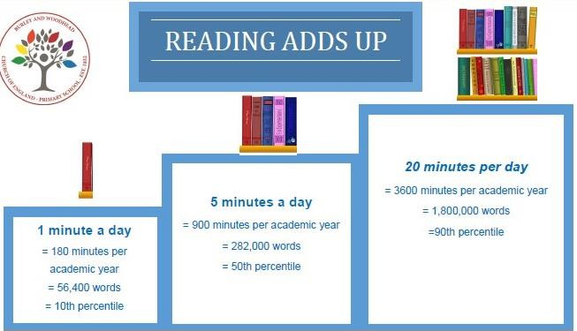

“I really like WCR reading because we get to read new books. When we read as a class, I enjoy getting to learn about what all of the different words in the story mean”

Year 3 Pupil

“I love reading because you get to learn new words and it's a challenge because you have to sound out the words and use your phonics”

Year 2 Pupil

“Reading is good for you!”

“It helps you learn more”

Year 1 Pupils 1987

“A small amount of reading each day makes an incredible difference!”

Nagy and Herman, 1987

# INTENT

# Phonics (reading and spelling)

At Boroughbridge Primary School and Nursery we believe that all our children can become fluent readers and writers. This is why we teach reading through *Little Wandle Letters and Sounds Revised*, which is a systematic and synthetic phonics programme. We start teaching phonics in Nursery/Reception and follow the [*Little Wandle Letters and Sounds Revised* progression,](https://www.littlewandlelettersandsounds.org.uk/wp-content/uploads/2021/06/Programme-Overview_Reception-and-Year-1.pdf) (see appendix 1) which ensures children build on their growing knowledge of the alphabetic code, mastering phonics to read and spell as they move through school.

As a result, all our children are able to tackle any unfamiliar words as they read. At Boroughbridge Primary School and Nursery, we also model the application of the alphabetic code through phonics in shared reading and writing, both inside and outside of the phonics lesson and across the curriculum. We have a strong focus on language development for our children because we know that speaking and listening are crucial skills for reading and writing in all subjects.

# Comprehension

At Boroughbridge Primary School and Nursery we value reading as a crucial life skill. By the time children leave us, they read confidently for meaning and regularly enjoy reading for pleasure. Our readers are equipped with the tools to tackle unfamiliar vocabulary. We encourage our children to see themselves as readers for both pleasure and purpose.

Because we believe teaching every child to read is so important, all staff are trained in the Little Wandle Letters and Sounds Revised Programme.

# IMPLEMENTATION

Please find below an overview of our approach:

|  |  |  |  |  |  |  |  |  |
| --- | --- | --- | --- | --- | --- | --- | --- | --- |
| **Nursery** | **Reception** | **Year 1** | **Year 2** | | **Year 3** | **Year 4** | **Year 5** | **Year 6** |
| **Little**  **Wandle**  **Foundations for Phonics** | **Little Wandle Letters and Sounds Revised Daily**  **Phonics Programme** | | | | **Specific ‘Rapid Catch Up’ phonics lessons as required in KS2** | | | |
| **Small group reading sessions**  **3 times a week - based on phonic phase and the 3-part read** | | | | **Specific group or individual sessions 3 times a week – based on phonic phase and the 3-part read** | | | |
|  |  | | **Whole class reading lessons**  **3 to 4 times a week (from Summer term for Y2)** | | | | |
| **Individual Reading Books to read in the classroom and take home and enjoy**  **School books, library books or books from home** | | | | | | | | |
| **Daily Reading for Pleasure / Story time where pupils listen to adults read a variety of genres** | | | | | | | | |

### Foundations for phonics in Nursery

* We provide a balance of child-led and adult-led experiences for all children that meet the curriculum expectations for ‘Communication and language’ and ‘Literacy’. These include:
  + sharing high-quality stories and poems
  + learning a range of nursery rhymes and action rhymes
  + activities that develop focused listening and attention, including oral blending
  + attention to high-quality language.
* We ensure Nursery children are well prepared to begin learning grapheme-phoneme correspondences (GPCs) and blending in Reception.

### Daily phonics lessons in Reception and Year 1

* We teach phonics for 30 minutes a day. In Reception, we build from 10-minute lessons, with additional daily oral blending games, to the full-length lesson as quickly as possible. Each Friday, we review the week’s teaching to help children become fluent readers.
* Children make a strong start in Reception: teaching begins in Week 2 of the Autumn term.
* We follow the [*Little Wandle Letters and Sounds Revised* expectations of progress:](https://www.littlewandlelettersandsounds.org.uk/wp-content/uploads/2021/06/Programme-Overview_Reception-and-Year-1.pdf)
  + Children in Reception are taught to read and spell words using Phase 2 and 3 GPCs, and words with adjacent consonants (Phase 4) with fluency and accuracy.
  + Children in Year 1 review Phase 3 and 4 and are taught to read and spell words using Phase 5 GPCs with fluency and accuracy.

### Daily Keep-up lessons ensure every child learns to read

* Any child who needs additional practice has daily Keep-up support, taught by a fully trained adult. Keep-up lessons match the structure of class teaching, and use the same procedures, resources and mantras, but in smaller steps with more repetition, so that every child secures their learning.
* We timetable daily phonics lessons for any child in Year 2 who is not fully fluent at reading or has not passed the Phonics Screening Check. These children urgently need to catch up, so the gap between themselves and their peers does not widen. We use the *Little Wandle Letters and Sounds Revised* assessments to identify the gaps in their phonic knowledge and teach to these using the Keep-up resources, and the *Rapid Catch Up Programme* from Spring onwards.
* If any child in Year 3 to 6 has gaps in their phonic knowledge when reading or writing, we plan phonics *‘Rapid catch-up’* lessons to address specific reading/writing gaps.

### Teaching reading

### Reading practice sessions three times a week

* We teach children to read through reading practice sessions three times a week. These
* are taught by a fully trained adult to small groups of approximately six children. We use books matched to the children’s secure phonic knowledge using the *Little Wandle Letters and Sounds Revised* assessments and book matching grids on pages 11–20 of ‘Application of phonics reading’
* Sessions are monitored by the class teacher, who rotates and works with each group on a regular basis.
* Each reading practice session has a clear focus, so that the demands of the session do not overload the children’s working memory. The reading practice sessions have been designed to focus on three key reading skills: decoding, prosody: teaching children to read with understanding and expression, and comprehension: teaching children to understand the text.
* In Reception these sessions start in Week 4. Children who are not yet decoding have daily additional blending practice in small groups, so that they quickly learn to blend and can begin to read books.
* In Year 2 and Key Stage 2, we continue to teach reading in this way for any children who are receiving phonics catch-up sessions.

### Home reading

* The decodable reading practice book is taken home to ensure success is shared with the family.
* Reading for pleasure books also go home for parents to share and read to children. We use the [*Little Wandle Letters and Sounds Revised* parents’ resources](https://www.littlewandlelettersandsounds.org.uk/resources/for-parents/) to engage our families and share information about phonics, the benefits of sharing books, how children learn to blend and other aspects of our provision, both online and through workshops.
* Notices go out to parents every year regarding the importance of reading at home, and encouraging children to read at least 3 times a week.

### Additional reading support for vulnerable children

* Children in Reception and Year 1 who are receiving additional phonics Keep-up sessions read their reading practice book to an adult daily.
* In addition to group reading and whole class reading, some children in KS2 read regularly with an adult on a one-to-one basis. These children will be identified following formative and summative assessments, pupil progress meetings and prioritising Pupil Premium, EAL and SEND and will include the bottom 20% of readers in each class.
* Interventions such as paired-reading, fluency and echo-reading will be used where deemed appropriate and effective.
* SEN phonics is also taught to children who struggle with the main phonics programme. These children will receive daily phonics teaching and reading with an adult.

### Ensuring consistency and pace of progress

* Every teacher in our school has been trained to teach reading, so we have the same expectations of progress. We all use the same language, routines and resources to teach children to read so that we lower children’s cognitive load.
* Weekly content grids map each element of new learning to each day, week and term for the duration of the programme.
* Lesson templates, Prompt cards and How to videos ensure teachers all have a consistent approach and structure for each lesson.
* The English Leader and SLT use the Audit and Prompt cards to regularly monitor and observe teaching; they use the summative data to identify children who need additional support and gaps in learning.

### Ensuring reading for pleasure

*‘Reading for pleasure is the single most important indicator of a child’s success.’* (OECD 2002)

*‘The will influences the skill and vice versa.’* (OECD 2010)

We value reading for pleasure highly and work hard as a school to grow our Reading for Pleasure pedagogy.

* We read to children every day. We choose these books carefully as we want children to experience a wide range of books, including books that reflect the children at Boroughbridge Primary School and Nursery and our local community as well as books that open windows into other worlds and cultures.
* Every classroom has an inviting book corner that encourages a love for reading. We curate these books and talk about them to entice children to read a wide range of books.
* In Nursery/Reception, children have access to the reading corner every day in their free flow time and the books are continually refreshed.
* There is a designated time in each class where adults read a ‘reading for pleasure’ text to the children from a range of genres; fiction, non-fiction and poetry. During this time, teachers or teaching assistants will read to the class; modelling prosody, expression and enjoyment of a text. This is in addition to any independent, “quiet reading time” which can be used at the discretion of each teacher at appropriate times within the classroom.
* The school library is made available for classes to use at designated times along with lunchtime library clubs.
* Children have the opportunity to vote on books for the Children’s Book Award. In EYFS and KS1, this is done weekly, with KS2 children reading books individually and passing on to others to vote.
* Children across the school have regular opportunities to engage with a wide range of Reading for Pleasure events (book fairs, author visits and workshops, national events, summer reading challenge at the library etc)

### Whole Class Reading

Whole class reading starts during the Summer Term of Year 2 at the discretion of the class teacher.

Whole class reading sessions in KS2 takes place three to four times a week. They provide children of all reading abilities the opportunity to be immersed in the same high-quality literature and the discussions that these texts promote. Sessions are planned and led by the teacher so each child has regular access to this expertise. Follow on teaching activities are intended to provide challenge for all children and support for those who need it whilst developing crucial analytical reading skills.

In planning these sessions, teachers use the VIPERS comprehension and questioning approach:

### Reading Vipers

We use the “VIPERS” approach to comprehension and questioning in classes through school. **VIPERS** is an acronym to aid the recall of the 6 reading domains as part of the UK’s reading curriculum. They are the key areas which we feel children need to know and understand in order to improve their comprehension of texts. Pupils are taught each skill through a range of high-quality texts and genres. The consistent approach when using terminology helps ensure pupils have a strong understanding and teachers have a specific focus in all reading sessions.

## VocabularyInfer Predict Explain Retrieve Sequence / Summarise

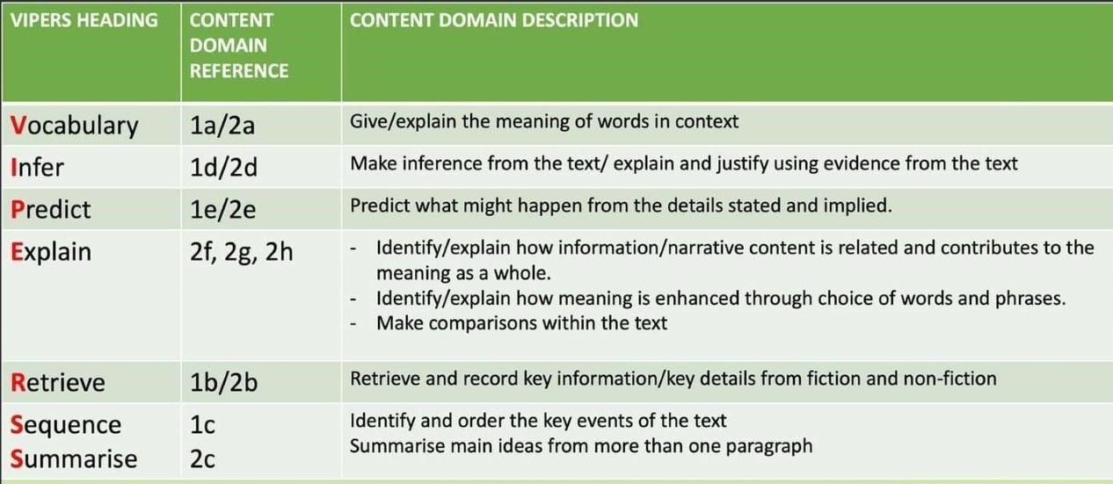

### Choice of texts

The majority of texts are chosen to align with our wider curriculum topics. This enables the pupils to connect with what they are learning, and what they are reading at a deeper level and strengthens their engagement with both. Other texts (including multi-media texts) are also used to ensure that the pupils experience a variety of genres and that they are able to apply their skills to more unfamiliar subjects.

# IMPACT

### Assessment

Assessment is used to monitor progress and to identify any child needing additional support as soon as they need it.

* [**Assessment for learning**](https://www.littlewandlelettersandsounds.org.uk/wp-content/uploads/2021/03/LS-KEY-GUIDANCE-GETTING-STARTED-ASSESSMENT-FINAL.pdf) is used:
  + daily within class to identify children needing Keep-up support
  + weekly in the Review lesson to assess gaps, address these immediately and secure fluency of GPCs, words and spellings.
* [**Summative assessment**](https://www.littlewandlelettersandsounds.org.uk/resources/my-letters-and-sounds/assessment-tools/) is used:
  + every six weeks to assess progress, to identify gaps in learning that need to be addressed, to identify any children needing additional support and to plan the Keep-up support that they need.
  + by the English Subject Lead and SLT and scrutinised through the *Little Wandle Letters and Sounds Revised* assessment tracker, to narrow attainment gaps between different groups of children and so that any additional support for teachers can be put into place.
* Teacher assessments are regularly completed against National Curriculum expectations. Standardised assessments take place in the form of past SATS papers for Year 2 and Year 6, and a NFER reading assessment in Autumn and Spring for Years 3-5. Children’s progress is tracked and informs future planning.

### Statutory assessment

Children in Year 1 sit the Phonics Screening Check. Any child not passing the check re-sits it in Year 2.

### Ongoing assessment of Phonics Catch-up

Children in Year 2 to 6 are assessed through their teacher’s ongoing formative assessment as well as through the half-termly *Little Wandle Letters and Sounds Revised* summative assessments.

# APPENDICES

* Appendix 1 – Glossary of Little Wandle Letters and Sounds Revised terminology
* Appendix 2 – Little Wandle Letters and Sounds Revised 2021: Programme progression

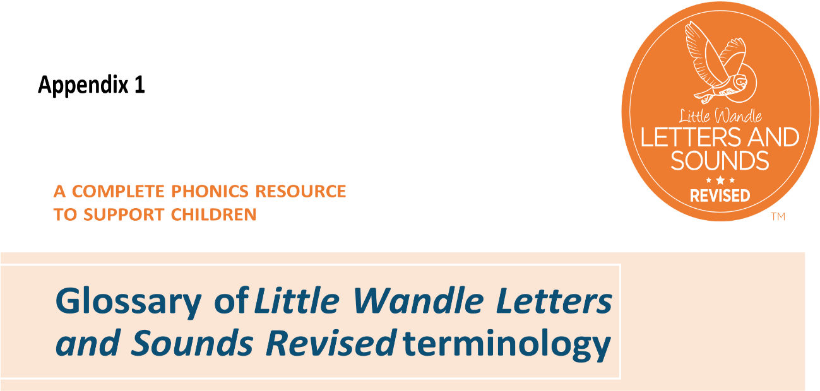

##### Adjacent consonants

Two or more consonants that come together in a word without any intervening vowel or vowels (for example, ‘d-r’ in ‘drop’, ‘s-t-r’ in ‘strap’). Adjacent consonants do not constitute a discrete unit of sound and are read by blending the individual consonant phonemes involved.

**Alien words**

A child-friendly term for ‘pseudo-words’.

##### Alphabetic code

The relationship between the sounds that can be identified in speech (phonemes) and the letters used to represent them in writing (graphemes).

##### Alternative pronunciation

A different way of pronouncing a grapheme. For example, the letters ‘ow’ can represent the sounds /ow/ as in ‘crown’ and /oa/ as in ‘snow’.

##### Alternative spelling

A different way of spelling a phoneme. For example, the sound /w/ can be represented in writing by ‘w’ as in ‘wave’ and ‘wh’ as in ‘what’.

##### Blend

To combine individual phonemes into a whole word, working all the way through from left to right. Once the GPCs involved have been learned, blending is the key process involved in reading words effectively. It is a skill that needs extensive practice. Practice in oral blending is very helpful, both before and during the process of learning to read. It is important to understand that blending sounds into a word is not simply a matter of saying them more quickly, nor of mixing them together like paint. Phonemes need to be joined into one continuous stream of sound to make a spoken word. Extensive practice, following teacher modelling, is the key.

##### Catchphrase

A type of mnemonic in the form of a memorable (often funny) phrase. Catchphrases are generally used in this programme to help children remember some of the later GPCs learned, where a picture alone might not give enough of a ‘hook’.

##### Chunk it up

To break up a longer word and read it one part (chunk) at a time, to avoid being overwhelmed and to ease the process of blending.

**Compound word**

A word made by joining two individual words together, for example, ‘houseboat’ is ‘house’ + ‘boat’.

##### Digraph

A grapheme using two letters to represent one phoneme. With children, we frequently reinforce it with the mantra *‘two letters, one sound’*. At the appropriate stage, it is useful for children to learn to use the term and to understand what it means.

##### Fluency

The ability to read accurately with speed and expression. Fluent readers read words automatically without needing to decode. It is at this point that we see them able to focus on comprehension and make sense of what is being read.

##### Formation phrase

A memorable phrase used to support the children in forming the letter correctly using directional vocabulary, such as ‘down’, ‘up’, ‘across’ and ‘over’.



**Under the snake’s chin, slide down and round its tail.**

##### GPC

This stands for grapheme–phoneme correspondence, the sound–letter relationship between each element of the alphabetic code. Written English is quite complex and does not have one-to-one grapheme–phoneme correspondence. The same phoneme can be represented by different graphemes in different words, and the same grapheme can represent different phonemes in different words. To ensure learning is systematic, and to avoid cognitive overload, this programme generally teaches one fairly common grapheme representation of each phoneme first. Alternative spellings of the same phoneme, and alternative pronunciation of the same grapheme are usually taught later, mostly in Phase

5.

##### Grapheme

A letter or group of letters used to represent a particular phoneme when writing. With children, we sometimes call this ‘a sound written down’, although, as with ‘phoneme’, it is helpful for children to learn to use the correct term from the beginning. The way graphemes are used to represent phonemes in our written language is known as the ‘alphabetic code’.

##### Group reading practice

A group reading session where the children read alongside an adult from books containing known GPCs and tricky words, and have the opportunity to apply and practise their knowledge. The children should be able to access these books with 90% accuracy. (Also known as ‘teaching reading with books’.)

##### Grow the code

To systematically and incrementally teach additional GPCs so that the range of words children can read continually extends.

##### Homograph

Homographs are words that have the same spelling but different meanings, for example, ‘pen’ (writing implement) and ‘pen’ (animal enclosure).

##### Homophone

Homophones are words that have the same pronunciation but different spellings or meanings, for example, ‘prey’ and ‘pray’.

##### Mnemonic

Any simple device used to assist memory. In this programme, it is a combination of an engaging picture with a letter and is used as a ‘hook’ to help children remember a particular GPC when they first learn it.

##### Multi-syllable word

A word with more than one syllable. Syllables are easy to recognise when words are spoken, but hard to distinguish in printed words until you know how to say them. The best way for children to learn to recognise syllables is to count (or clap) them when reciting known rhymes, songs, and so on.

##### Oral blending

A technique for the early practice of blending. The teacher articulates each phoneme in a word separately, in order, and children respond by saying the whole word aloud. Alternatively, they can be asked to blend the word silently and show they have done so by responding with some action, for example, touching their head, after the teacher has pronounced the separate phonemes in the word ‘head’. Such practice is valuable both before and during the early stages of learning to read. (Also known as ‘sound-talk’.) **Orthographic store**

Children learn to read by first sounding and blending words, and then reading them ‘straight off’, without overt sounding and blending. Once this has been practised sufficiently, recognition of these words becomes automatic and they are held as an orthographic store in a highly specialised area of the brain that expert neurologist Stanislas Dehaene calls ‘the brain’s letterbox’. This orthographic store, and the instantaneous recall it enables, is the basis of fluent reading. It is important to remember that the orthographic store is most effectively built up through extensive practice of the sounding–blending– reading process, which establishes the necessary neural pathways, not through trying to memorise countless whole words.

**Overt blending aloud**

Sound-talking aloud every phoneme in turn before blending them together to form the word.

##### Phoneme

The smallest unit of sound that can be identified in words. We sometimes simply call this a ‘sound’, although it is helpful for children to use the term ‘phoneme’ from the beginning of our programme. (Note: We do not usually notice discrete sounds in words. We deliberately separate them out so that children can learn how our writing–reading system works. Children are first helped to identify the separate sounds in words through oral blending and segmenting, and this is reinforced as they begin to work through our systematic synthetic phonics programme.)

##### Phonetically plausible

Comprising grapheme–phoneme correspondences that can be found in English words, even if they are not correct spellings of the (or any) actual word, for example, ‘thor’ instead of ‘thaw’.

##### Phonics screening check

A statutory national assessment in England, conducted internally by schools towards the end of Year 1. Its sole purpose is to determine whether a child can phonically decode single words to an annually predetermined national standard.

##### Phonics

The method by which we teach children to read by recognising the connections between the sounds of spoken words (phonemes) and the letters that are used to write them down (graphemes).

##### Point and sweep

A technique for reinforcing the process of sounding and blending involving the teacher pointing to each phoneme in a word, in sequence from left to right, and then sweeping a finger below the word, again from left to right, to indicate the blending. It can be used with the teacher and/or children vocalising each stage, or as a reinforcement to silent sounding and blending as children become more confident.

##### Prefix

A recognisable unit of language added to the beginning of a word to change its meaning.

For example, ‘rewrite’ is ‘write’ with ‘re–’ added at the beginning, so ‘re–’ is the prefix. Examples of other common prefixes are ‘un–’, ‘dis–’, ‘sub–’. Prefixes usually carry a particular meaning, whatever word they are applied to.

##### Prosody

The rhythmic and intonational aspect of speech that manifests as expressive reading. It comprises timing, phrasing and intonation, and helps to convey meaning and add ‘life’ to reading.

##### Pseudo-words

Simple, phonetically plausible ‘words’ that don’t actually occur in the English language; used (as in the Phonics screening check) to assess whether a child can correctly read a word they haven’t seen before, using phonic decoding; use should be confined to assessment.

**Reading**

The process of looking at written symbols and getting meaning from them – making meaning from print.

##### Regional pronunciation

In a few instances, regional accents result in a noticeably different pronunciation of a phoneme in some words. It is recommended that teaching is adapted to suit this. For example, whereas in southern areas it will be necessary to teach an /ah/ sound as an alternative pronunciation for the vowel in words like ‘bath’, in some northern regions, where such words are consistently pronounced with a short form of the vowel, this will not be necessary. In this programme, the progression chart indicates where this is most likely to apply.

##### Revisit and review

The first part of the lesson where the core purpose is to activate prior knowledge – bringing prior learning to the forefront of the children’s minds and promoting the transference of working memory into long-term memory.

##### Segment

To identify each of the individual phonemes in a word, working all the way through from left to right. This is an important first stage of writing (spelling) a word but needs to be practised orally first. Counting the phonemes is often helpful in reinforcing this process.

##### Sound button

A graphic device to help children recognise the separate phonemes in a printed word. Sound buttons can be used as a support in the early stages of learning. For each word, a dot is placed under any single-letter grapheme and a short horizontal line under the group of letters that form a digraph or trigraph, as shown below.

bird

**Sound talk**

See ‘Oral blending’, above.

**Speedy sounds**

The rapid recall of previously taught GPCs.

**Speedy words**

Fluent reading of previously read words containing known GPCs that are read without blending.

##### Split vowel digraph

A digraph representing a vowel sound where its two letters are split by an intervening consonant (for example, ‘a_e’ in ‘take’). Despite having a consonant in between them, the two letters involved (here ‘a’ and ‘e’) still count as one digraph, making one sound. The vowel sound is pronounced at the position of the first of the two letters of the digraph (that is, in the middle of ‘take’). At early learning stages, a split digraph is often highlighted with a short line joining the two halves of the digraph above the intervening consonant, as shown below.

take

##### Suffix

A recognisable unit of language added to the end of a word to change its form, such as the tense of a verb. For example, ‘playing’ is ‘play’ + ‘–ing’, so ‘–ing’ is the suffix. Examples of other common suffixes are ‘–er’, ‘–ed’, ‘–est’.

##### Tap in/tapping in

The process by which the teacher listens in to individual children as they are engaged in reading their book during group reading practice.

**Teaching reading with books** See ‘Group reading practice,’ above.

##### Tricky words

High-frequency words that, although decodable in themselves, cannot be decoded by children using the GPCs they have been taught up to that point. Not all high-frequency words are ‘tricky words’. Many tricky words cease to be tricky in the later stages of our programme, as more GPCs are learned.

##### Trigraph

A grapheme using three letters to represent one phoneme. With children, we frequently reinforce it with the mantra *‘three letters, one sound’*. At the appropriate stage, it is useful for children to learn to use the term and to understand what it means.

**Vocabulary**

All of the words that a person knows and uses within their language.

##### Vowel sound

Although we have five vowel letters in English, each one can be pronounced in different ways and there are, therefore, far more than five vowel phonemes (vowel sounds). Each one has a short vowel form, with a fairly staccato pronunciation; these are the vowel sounds heard, for example, in ‘hat’, ‘bed’, ‘big’, ‘hot’ and ‘tub’. Each also has a more elongated pronunciation, the long vowel form heard, for example, in ‘play’, ‘seed’, ‘high’, ‘blow’ and ‘tube’. There are, additionally, more complex vowel forms, for example, those heard in ‘bear’ and ‘farm’. Graphemes for short vowel phonemes are the easiest to learn and are taught first. Most GPCs for long vowels involve digraphs or trigraphs and are taught later, generally in Phase 5.

##### Whisper blending

An intermediary stage that can help children bridge the gap between sounding and blending aloud and doing the process silently ‘in their head’.

# Appendix 2

